WORK-CASE №2

1. 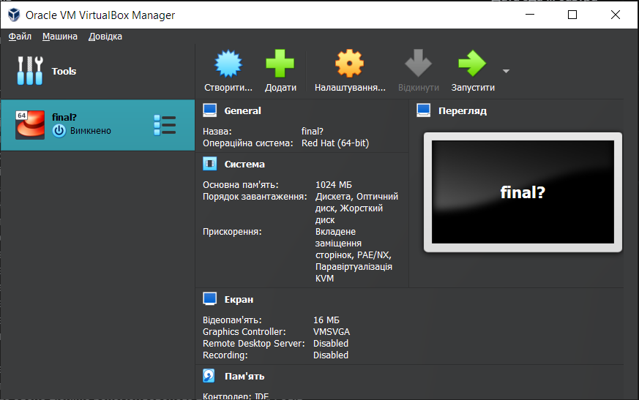 Install a type II hypervisor on your home workstation - Virtual Box, VMWare Workstation, Hyper-V (or another one of your choice).
2. Describe a set of basic actions in the hypervisor you installed:

* Creating a new virtual machine:

1. 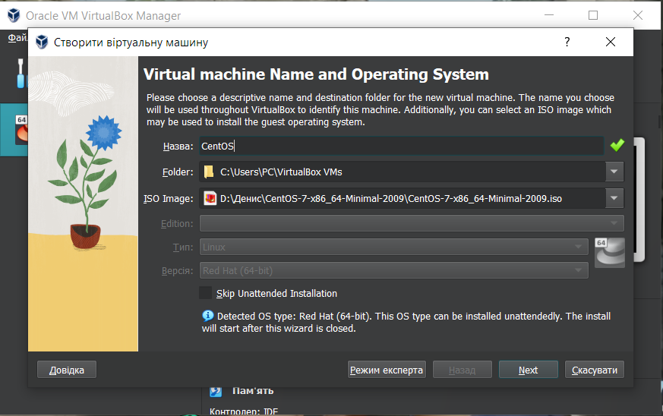Click on the “Machine” button and then on “New…”;
2. In the "Create Machine" Menu you need to give a name to your virtual machine, choose a folder where your machine is going to be situated, choose the ISO file or type and version of OS you want to be on the virtual machine and click "Next";
3. You need to choose the amount of base memory and processors;
4. In the next menu, you need to allocate space on the hard disk to the virtual hard disk, click “Next” button;
5. 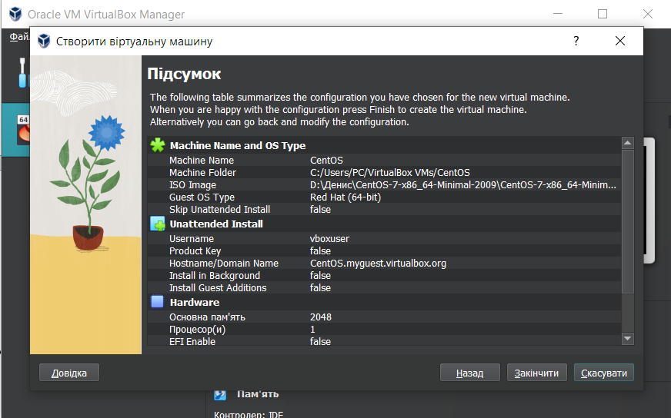In this menu you can see the summary settings of the virtual machine, click “Finish” and your machine is created;

* Selecting/adding equipment available for the virtual machine;

1. First of all you need to go to the virtual machine’s settings;

* Setting up the network and connecting to Wi-Fi points;
* Ability to work with external media (flash memory).